### Institutions

Institutions represent the participating data contributors within the HIE. An institution might be a hospital, a practice, a state entity (e.g., Medicaid), an insurance provider, or another HIE. Each user must be associated with an institution in order to view patient data. Users may be associated with more than one institution.

To add an institution to a user's account, select from the **Add an Institution** dropdown. The institution will automatically be added to the user's profile. Repeat this process to add additional institutions.

To add an institution to a user's account, select from the **Add an Institution** dropdown menu.

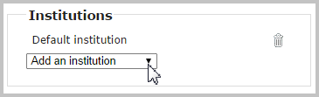

To add more than one institution, wait until the *Added* confirmation message appears. Then, select the next institution, if applicable.

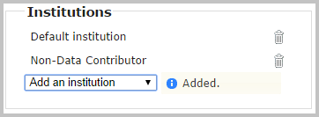

To delete an institution, click on the trash can icon next to an added institution. A *Deleted* confirmation message will appear briefly.

